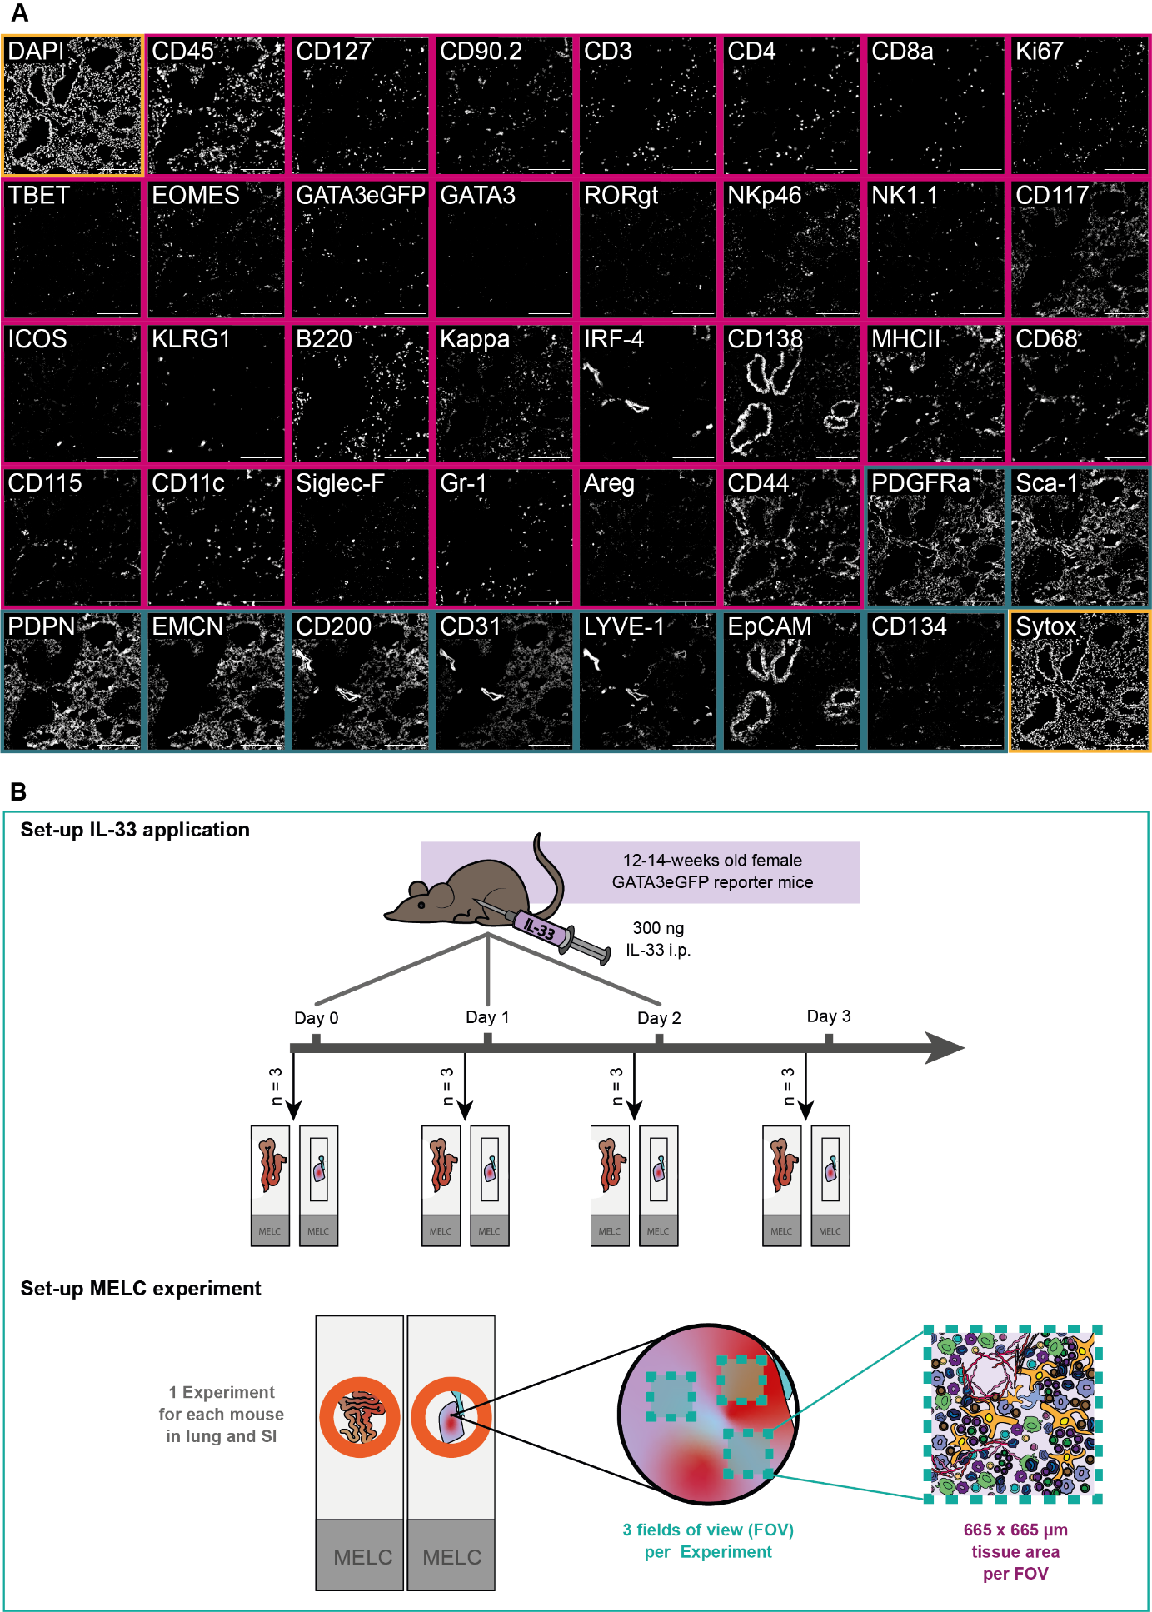

**Figure 1: (A)** Overview of an established 40-marker panel in an exemplary tissue region of murine lung. Each image shows the same tissue region stained for diverse immune markers (magenta) and structural markers (darkcyan), as well as nuclei stains (yellow). Scale bar represents 200 µm. **(B)** Schematic of the experimental set-up of the IL-33 systemic inflammation model and the MELC experiment. In short, 12-14-week-old GATA3eGFP reporter mice were i.p. injected with 300 ng IL-33 on up to 3 consecutive days. 24 h after the last dose, organs were harvested and processed for cyclic IF (MELC). In each MELC experiment, three regions of interest (fields of view = FOV) were acquired, each measuring 665 x 665 µm.

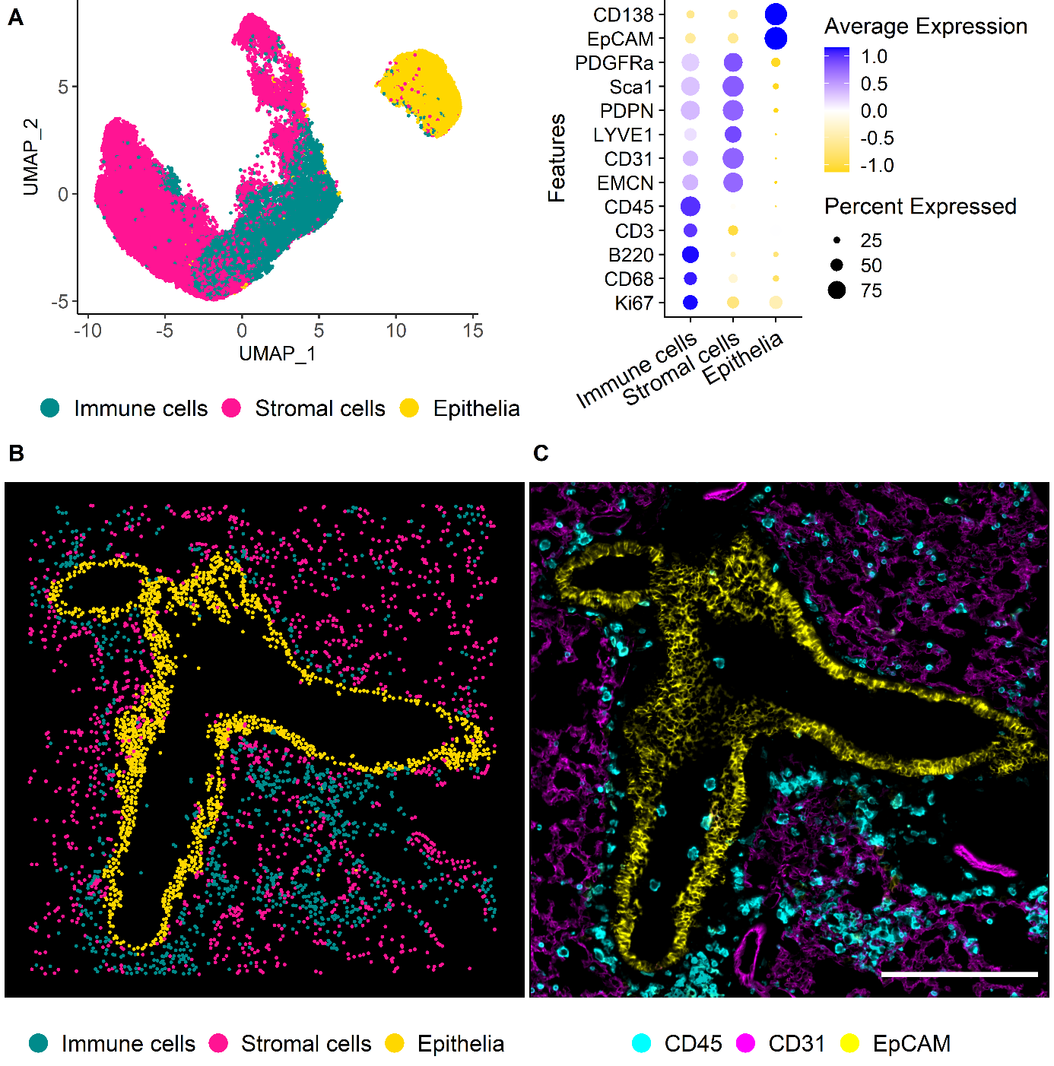

**Figure 2: (A)** UMAP representation of the first level of annotation (AL1) in murine lung tissue showing the three clusters annotated as Immune cells, stromal cells, and epithelia based on the feature profiles shown in the dot plot beside. **(B)** Annotated clusters of AL1 mapped in X and Y. Annotations are colored by cell type with immune cells (Cyan), vessels (Magenta), and epithelia (Yellow). **(C)** IF overlay of CD45 (Cyan), CD31 (Magenta), and EpCAM (Yellow) of the same FOV shown in B. Scale bar: 200 µm.

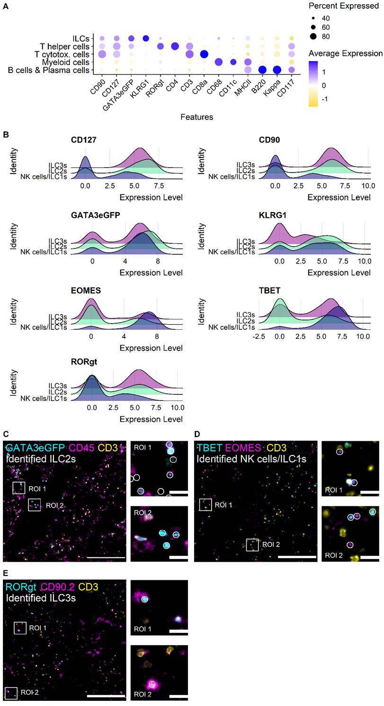

**Figure 3: (A)** Dot plot showing the marker profiles of the annotated immune cell types in murine lung data including ILCs. **(B)** Ridge plots of ILC-related markers showing the levels for the identified ILC subsets in murine lung NK cells/ILCs, ILC2s, and ILC3s. **(C)** Visual validation NK cells/ILC1s. Cells are depicted on IF overlay of TBET (Cyan), EOMES (Magenta), CD3 (Yellow). **(D)** Visual validation of ILC2s. Cells are overlayed with GATA3eGFP (Cyan), CD45 (Magenta), and CD3 (Yellow). **(E)** Visual validation of identified ILC3s. Cells annotated as ILC3s are depicted on IF overlay showing RORgt (Cyan), CD90.2 (Magenta) and CD3 (Yellow). (D-E) Identified cells are depicted as white circles, each circle representing one cell. White boxes mark regions of interest that are zoomed in respectively on the right side. Scale bars represent 200 µm in overviews, and 20 µm in ROIs.

**Ein Bild, das Text, Screenshot, Schrift, Reihe enthält.
**

**Supplementary Fig. 1:** Dot plot showing the feature profile of all annotated cell types including immune and non-immune cells in the analyzed murine lung data.

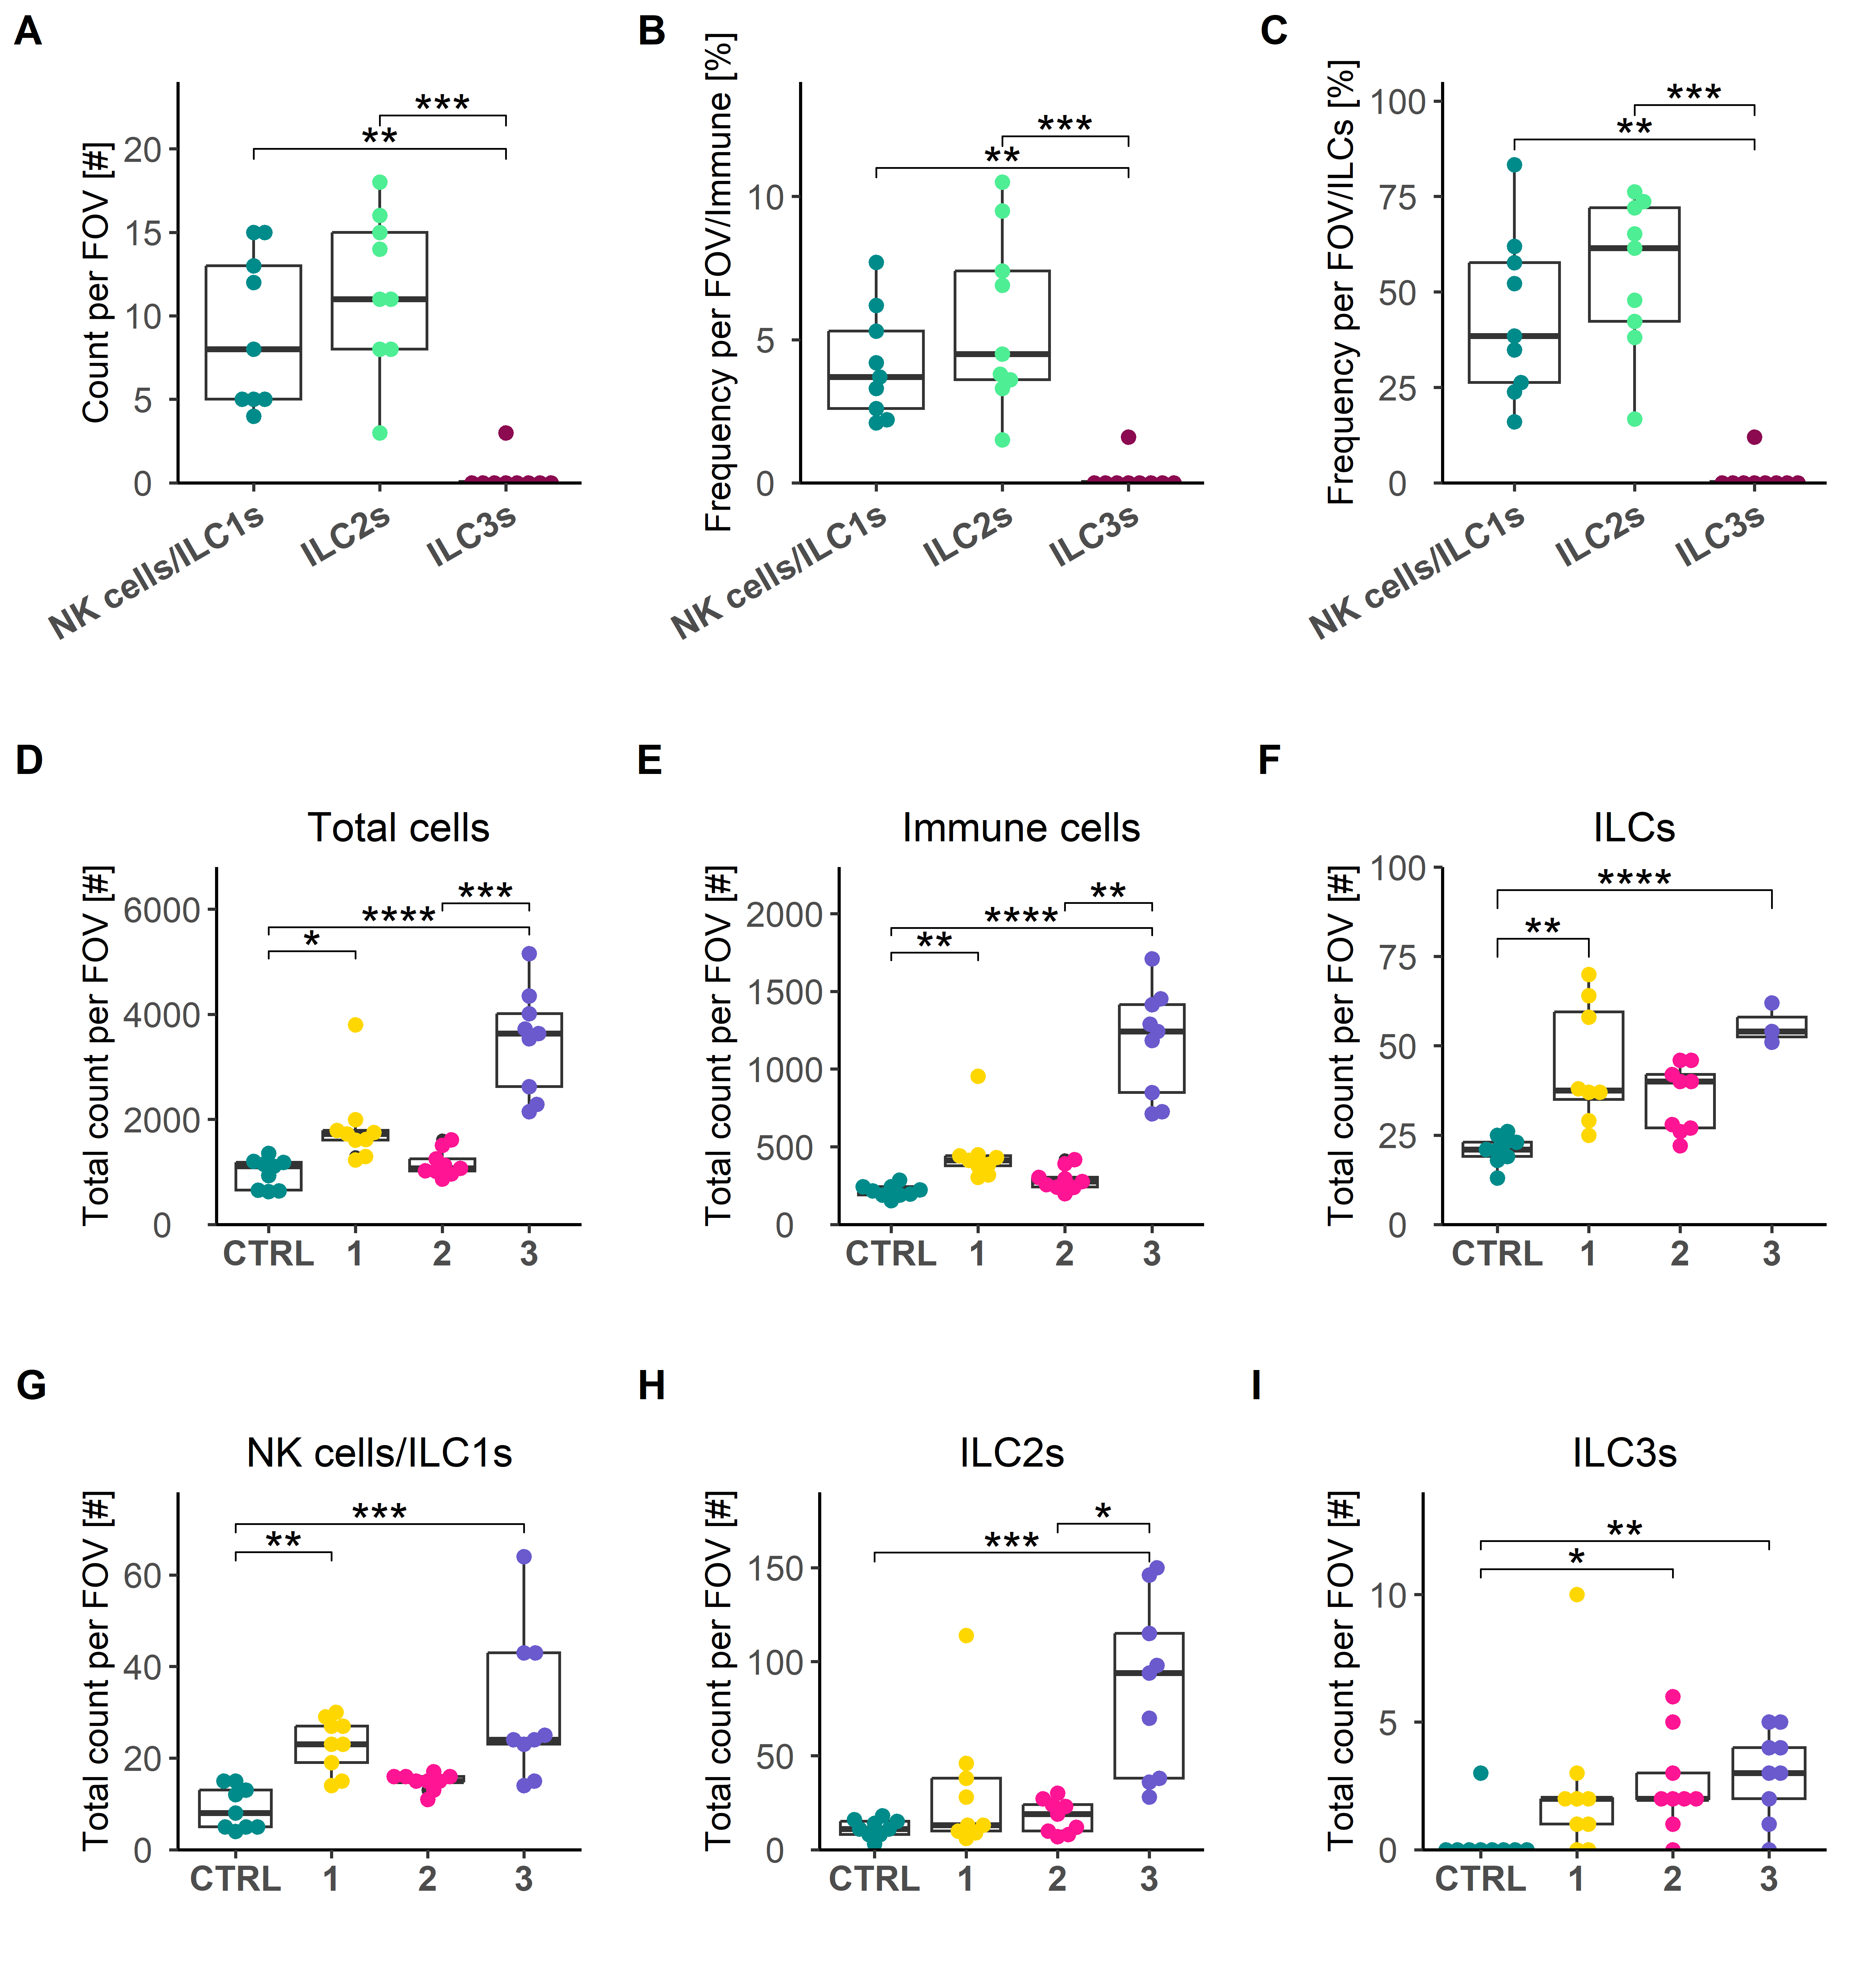

**Figure 4: (A)** Box plot depicting the total number of analyzed cells per FOV split by condition. **(B)** Box plot depicting the total number of analyzed immune cells per FOV split by condition. **(C)** Box plot depicting the total number of analyzed ILCs per FOV split by condition. **(D-F)** Box plots showing the total count of all annotated cells, immune cells, and ILCs per analyzed condition per FOV, respectively. **(G-H)** Box plots showing the total count of NK cells/ILC1s, ILC2s, and ILC3s per analyzed condition per FOV, respectively. (A-I) FOV = analyzed fields of view; n = 9; each dot represents one analyzed FOV.

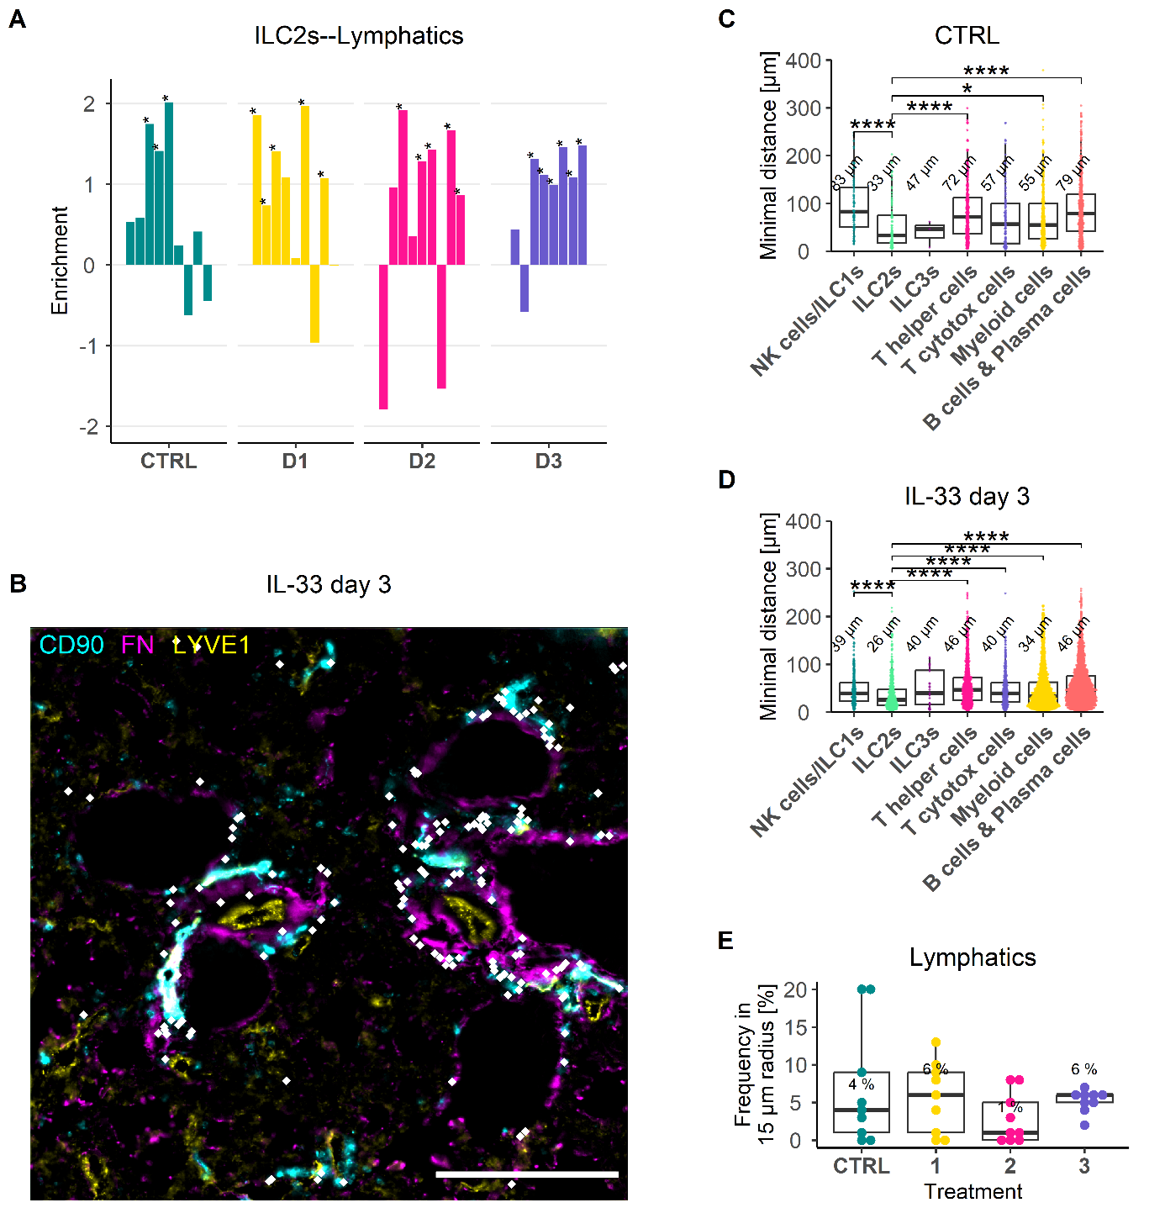

**Figure 5: (A)** Bar plot showing the results of the co-enrichment analysis of ILC2s and lymphatics. Each bar represents one analyzed FOV. Asterisks mark p-value lower than 0.05. **(B)** IF overlay of CD90.2 (Cyan), FN (Magenta) and LYVE1 (Yellow). White dots mark identified ILC2s. Each dot represents one identified cell. Scale bar: 200 µm. **(C)** Box plot depicting the minimal distances of the identified immune cell types to lymphatics as reference cells under healthy conditions. Number represents the median minimum distance for the respective cell type in µm. **(D)** Box plot depicting the minimal distances of the identified immune cell types to lymphatics as reference cells at IL-33 day 3. Number represents the median minimum distance for the respective cell type in µm. **(E)** Box plot showing the result of the CIN analysis showing the frequency of lymphatics in a 15 µm radius around ILC2s used as reference cells. Number represents the median frequency at each condition in %. **(C-D)** Each dot represents one cell from 9 analyzed FOVs per condition.

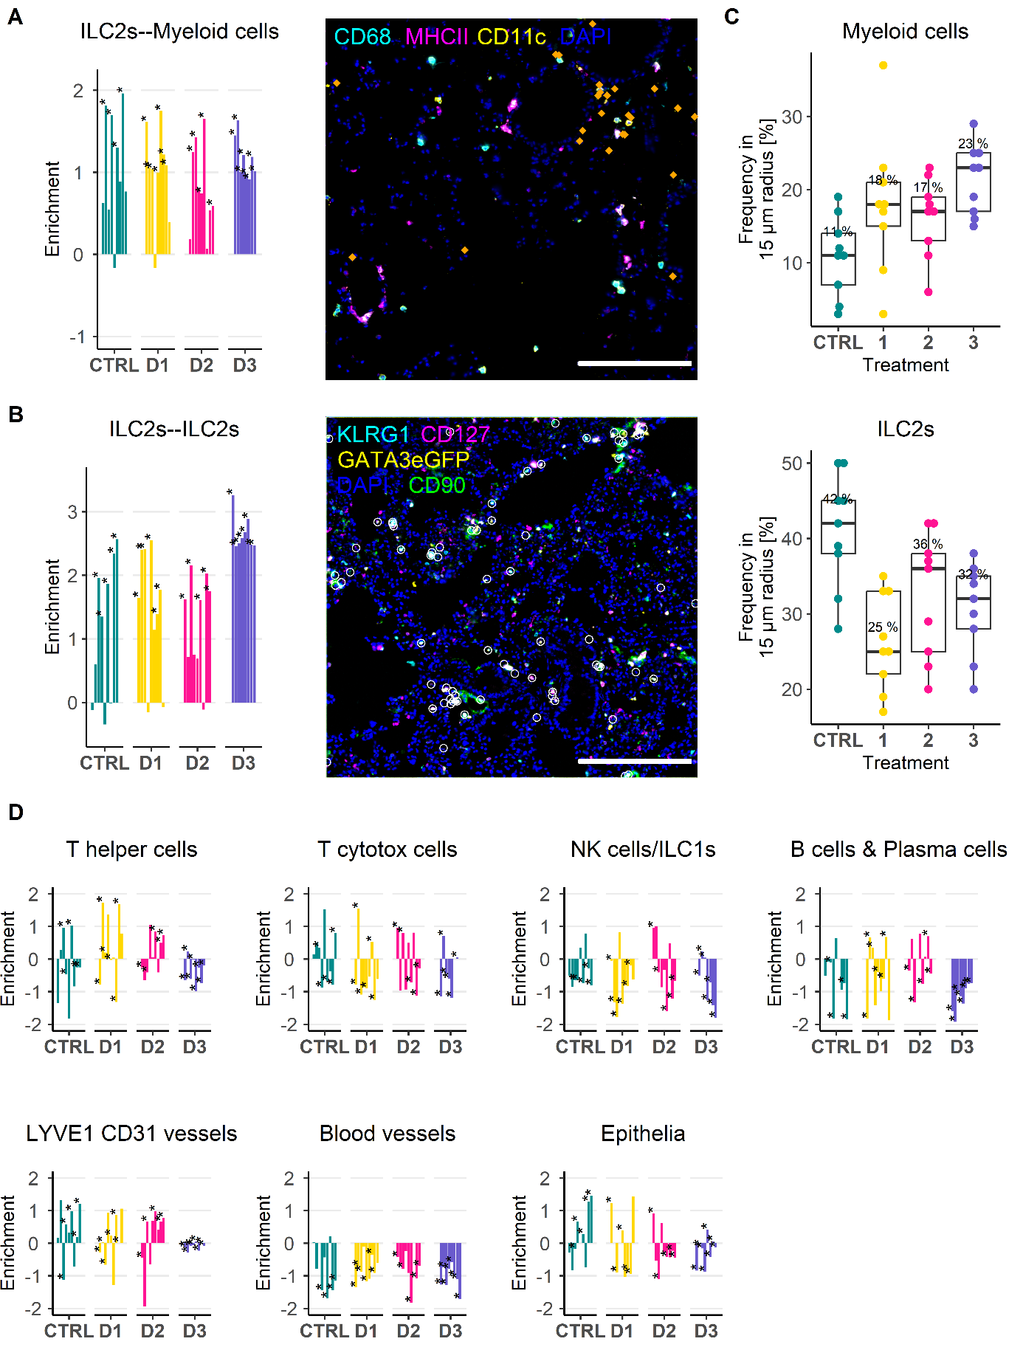

**Supplementary Fig. 2: (A)** Bar plot showing the results of the co-enrichment analysis of ILC2s and myeloid cells. Each bar represents one analyzed FOV. IF overlay stained for CD68 (Cyan), MHC II (Magenta), CD11c (Yellow), and DAPI (Blue), and with identified ILC2s depicted as dots (Orange). Scale bar represents 200 µm. Each dot represents one identified ILC2. **(B)** Bar plot showing the results of the co-enrichment analysis of ILC2s and ILC2s. **(C)** Box plot depicting the results of the CIN analysis of ILC2s of myeloid cells (upper) and ILC2s (lower). **(D)** Overview of the results of the co-enrichment analysis of ILC2s with other identified immune and non-immune cells.

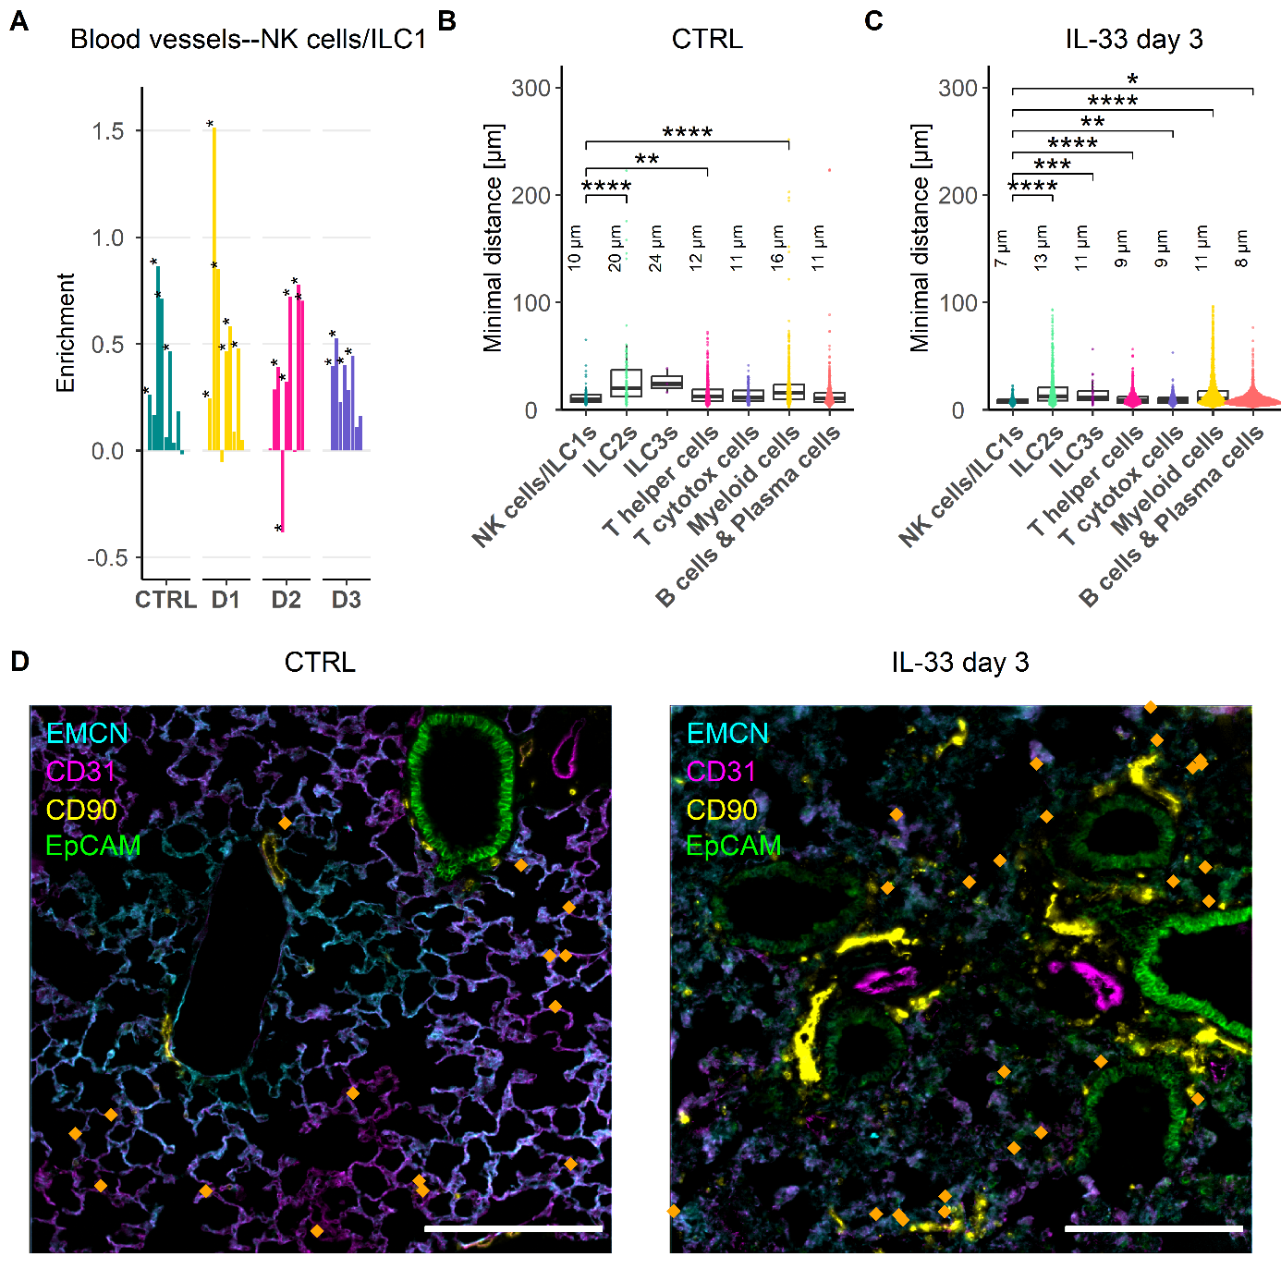

**Figure 6: (A)** Bar plot showing the results of the co-enrichment analysis of NK cells/ILC1s and blood vessels. Each bar represents one analyzed FOV. **(B)** Box plot depicting the minimal distance of identified immune cell types to blood vessels under healthy conditions in murine lungs. **(C)** Box plot depicting the minimal distance of identified immune cell types to blood vessels at IL-33 day 3 in murine lungs. **(D)** IF overlays of EMCN (Cyan), CD31 (Magenta), CD90 (Yellow), and EpCAM (Green) depicted with identified NK cells/ILC1s on top as dots (Orange) in murine lung under healthy conditions (Left) and at IL-33 day 3 (Right). Scale bar represents 200 µm. Each dot represents one identified cell.